**Digital Signal Processing Lab**

**Lab Report # 03**



Submitted By: **AWAIS SADDIQUI**

Registration No:  **21PWCSE1993**

Section: **“A”**

“On my honor, as student at University of Engineering and

Technology, I have neither given nor received unauthorized.

assistance on this academic work”



**Student Signature: ______________**

Submitted to:

**Sir Yasir Saleem Afridi**

**Department of Computer Systems Engineering**

**University of Engineering and Technology, Peshawar.**

**CSE 309L: Communication Systems**

|  |  |  |  |  |
| --- | --- | --- | --- | --- |
| **Demonstration of Concepts** | **Poor (Does not meet expectation (1))**  The student failed to demonstrate a clear understanding of the assignment concepts | **Fair (Meet Expectation (2-3))**  The student demonstrated a clear understanding of some of the assignment concepts | **Good (Exceeds Expectation (4-5)**  The student demonstrated a clear understanding of the assignment concepts | **Score**  **30%** |
| **Accuracy** | The student mis-configured enough signal processing settings that the computer couldn't function properly. | The student configured enough signal processing settings that the computer partially functioned | The student configured the signal processing settings that the computer fully functioned | **30%** |
| **Following Directions** | The student clearly failed to follow the verbal and written instructions to successfully complete the lab | The student failed to follow the some of the verbal and written instructions to successfully complete all requirements of the lab | The student followed the verbal and written instructions to successfully complete requirements of the lab | **20%** |
| **Time Utilization** | The student failed to complete even part of the lab in the allotted amount of time | The student failed to complete the entire lab in the allotted amount of time | The student completed the lab in its entirety in the allotted amount of time | **20%** |

***Study of Continuous-Time Signal using MATLAB***

**Unit Sample sequence:**

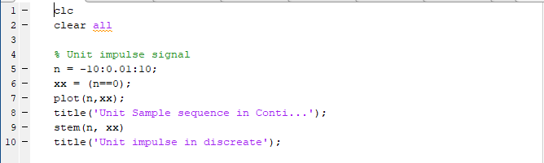

**Output:**

**Unit Step Signal:**

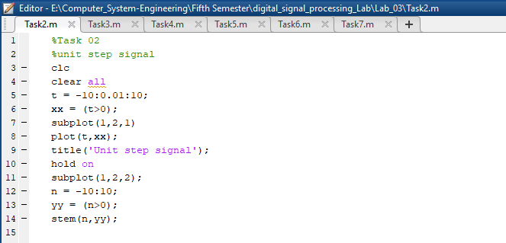

**Output:**

**Ramp Signal:**

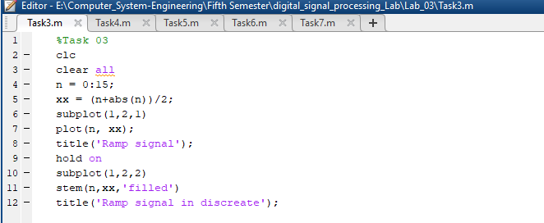

**Output:**

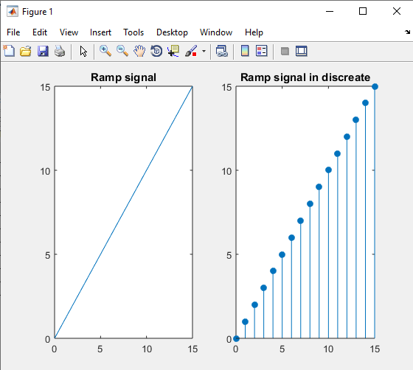

**Parabolic Signal:**

**Output:**

**Triangular Signal:**

**Output:**

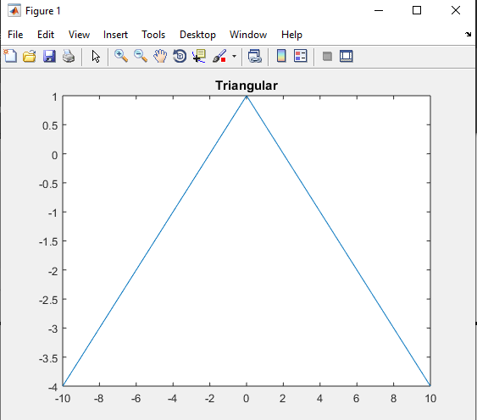

**Sinc Signal:**

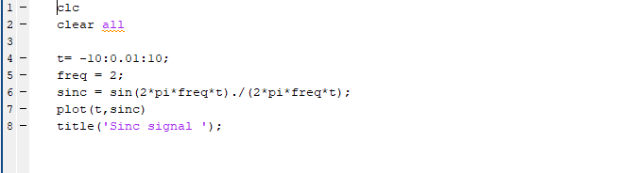

**Output:**

**Sinusoidal Signal:**

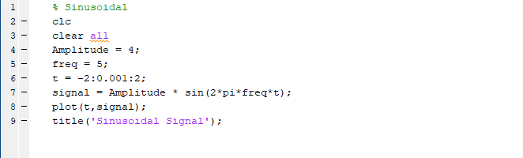

**Output:**

